# Assignment No:5

# Data Visualization Practical

## 1) Problem Statement

Download heart dataset from following link.

<https://github.com/mwaskom/seaborn-data/blob/master/car_crashes.csv>

## Visualize the data using R/Python by plotting the graphs for assignment no. 1 and 2. Consider a suitable data set.

## a) Use Scatter plot, bar plot, Box plot and Histogram

## OR

## b) Perform the data visualization operations using Tableau for the given dataset.

## 2) Libraries Used

**Python:  
Pandas:** For data manipulation and analysis.  
**Matplotlib:** For creating static, interactive, and animated visualizations in Python.

## 3) Theory

Data visualization is a graphical representation of information and data. By using visual elements like charts, graphs, and maps, data visualization tools provide an accessible way to see and understand trends, outliers, and patterns in data.

## 4) Methods

The methods used include creating a scatter plot to observe the relationship between variables, a bar plot to compare variables, a box plot to understand the distribution of the data, and a histogram to visualize the frequency distribution of a dataset.

## 5) Advantages

Advantages of data visualization include:

* • Quick, efficient transfer of information.
* • Easier to understand trends and patterns.
* • Aid in decision making by providing a clear picture of the situation.

## 6) Disadvantages

Disadvantages of data visualization include:

* • Misleading if not accurately designed.
* • Overcomplexity can lead to confusion.
* • Requires a certain level of skill to interpret correctly.

## 7) Working

This section outlines the step-by-step creation of each type of plot used in the practical, explaining the choice of data and the insights each plot provides.

**8) Diagram**

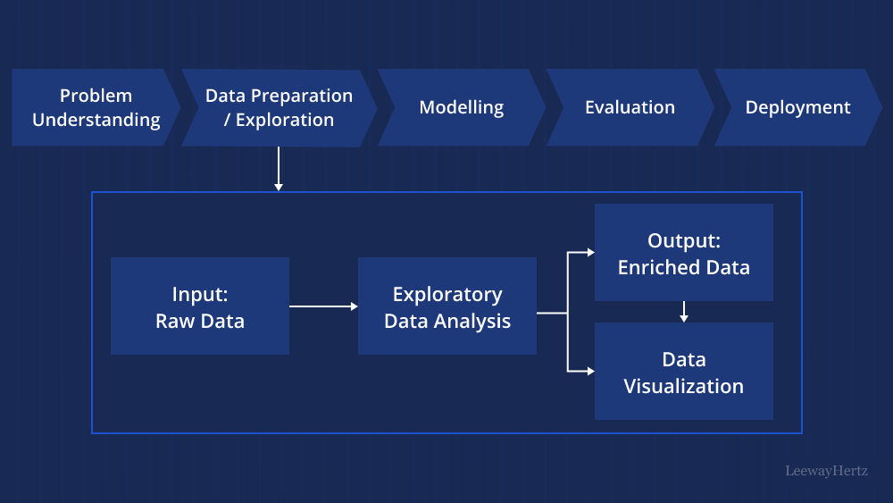

## 8) Conclusion

The practical exercise demonstrates the effectiveness of various types of data visualizations in revealing insights from the data, enhancing the understanding of complex patterns and relationships.